**Page 1 CREATING AN INFORMED, KNOWLEDGEABLE, AND CONNECTED STUDENT WORKFORCE IN THE OIL AND GAS INDUSTRY**

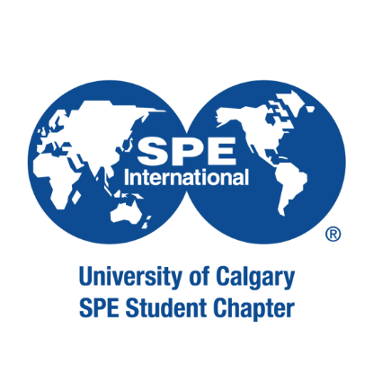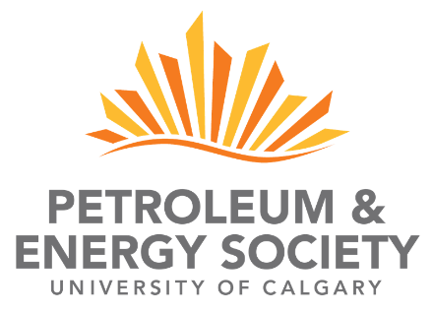

**2023**

**October, ATCE (US/Dubai)**

**2023 PETROBOWL UNIVERSITY OF CALGARY TEAM**

## PETROBOWL APPLICATION

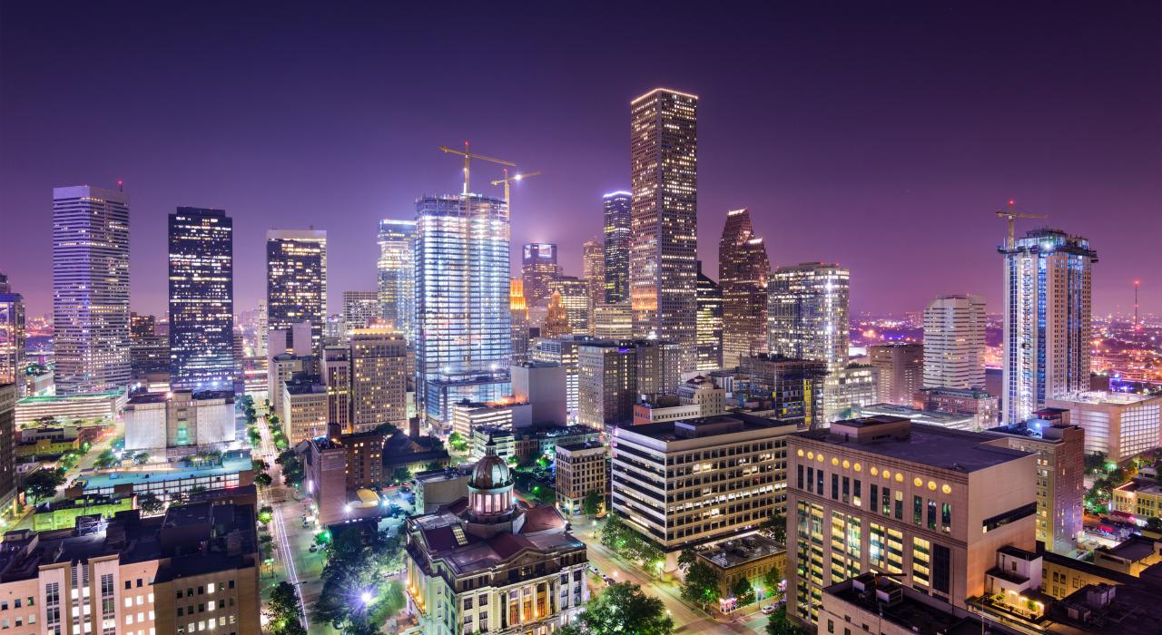



The Society of Petroleum Engineers (SPE) Annual Technical Conference and Exhibition (ATCE) is a leading global conference in the upstream (exploration and production) oil and gas industry. The event brings together thousands of professionals from around the world each year to share the latest research and technological advances in the industry through multiple sessions and an industry exhibition. The conference also includes excellent networking opportunities and several events especially for students and young professionals. Next year's conference will either be held in US or Dubai. Qualifying for the PetroBowl will result in an automatic invitation to this amazing event!

**To learn more, please visit:** [https://www.spe.org/events/calendar/](http://www.spe.org/events/calendar/)



Held each year in conjunction with the SPE ATCE, the PetroBowl competition matches university student chapter teams against one another in a fast-paced trivia competition within a bracket-style tournament. The competing teams are challenged to answer technical, historical, and non-technical questions associated with the oil and gas industry.

This will be 15th year that the University of Calgary is represented in the PetroBowl competition. The team will consist of five student competitors from the Schulich School of Engineering and Geoscience Department. Moreover, with the recent switch towards energy transition and the application of data science in the industry, we will be looking forward to welcoming students with energy & environmental engineering and data engineering backgrounds. This is the 8th year the SPE has administered separate Regional Qualifiers for entrance into the global competition held at the ATCE.

The 2023 North American Regional Qualifiers bracket features teams from all the top SPE Student Chapters in North America. The top 5 placed winners from the Regional Qualifiers will compete in October in the 2023 world championship bracket.

This year, the North American Regional Qualifiers will be held in conjunction with the SPE North America Student Symposium, which usually takes place in February in Oklahoma and is an excellent opportunity to network with students and industry professionals from across the continent. This will be an event not to be missed!

**To learn more about this competition, please visit:** [https://www.spe.org/students/petrobow](http://www.spe.org/students/petrobowl/)l/

**To learn more about the Student Symposium, please visit:** https://www.spe.org/events/en/2022/symposium/22nass/north-american-student-symposium



In order to apply to attend the 2023 SPE North American Regional Qualifiers, the PES executive council has outlined the following requirements. To attend you **must**:

* Be in good academic standing at the University of Calgary - all disciplines encouraged to apply
* Be a full-time student in the 2022-2023 academic year (i.e. not graduating in April)
* Own a PES and SPE membership for the 2022-2023 academic year (membership is not required to apply but will be required if selected to attend)
* SPE International membership ID number is a mandatory requirement to register in the competition (The Executive Members of PES - Petrobowl will help in the registration of new members and renewal of expired membership)
* Have a valid passport for entry to the United States that does not expire within 6 months of the conference dates
* Be able to pay the trip costs upfront; refunds will be made when funding is received
* Be prepared to take the necessary time off from school
* Be committed to representing the Petroleum & Energy Society, the University of Calgary, and our country professionally while at the conference
* Be prepared to attend all pre and post-conference meetings as scheduled by the PES Council, and contribute to the post-conference report
* Be willing to study for the PetroBowl competition in the limited time available (5-7 hours/week)

### Previous experience in the industry would be considered an asset

* **First and Second years students are encouraged to apply and may be invited to the team's review sessions for a potential opportunity to join the team in future years**



In order to qualify for the PetroBowl team at the 2023 SPE North American Regional Qualifiers, you must complete and submit the following documentation **no later than December 15th**:

* Cover letter (1 page max, see pages 5-7)
* Completed Application (Please type answers in Adobe, no handwritten responses)
* Resume (2 pages max, include relevant courses, competitions, and work experience)
* To submit an application, you must send your completed forms in ONE document in the order listed above via email to: [muhammad.khan21@ucalgary.ca](mailto:muhammad.khan21@ucalgary.ca) or [freider.tellezduran@ucalgary.ca](mailto:freider.tellezduran@ucalgary.ca)



You are required to submit a cover letter describing your interests in attending the 2023 SPE North American Regional Qualifiers and participating in the PetroBowl competition. Your cover letter must be no longer than 1 page and should be addressed to PES Directors of PetroBowl (hard copy not required, please send via email):

### Muhammad Hassan Khan, Co-Director of PetroBowl



### Freider Nicolas Tellez Duran, Co-Director of PetroBowl

















|  |  |  |  |
| --- | --- | --- | --- |
| **Areas** | **Score** | **Areas** | **Score** |
| Production /Operations | **/** | Drilling/Completions | **/** |
| Reservoir/Geology/Geophysics | **/** | Process/Facilities/Infrastructure | **/** |
| Physics, Chemistry, Fluid mechanics | **/** | Technology/ Offshore operations | **/** |
| History / Statistics /safety | **/** | Data analysis / Sustainability | **/** |

1. Training for the PetroBowl competition will be done between November 2022 and February 2023. Are you able to commit your time to team training throughout the upcoming months (Yes or No)? Please indicate any regular commitments that may prevent you from doing so:





* + I have read and understand the eligibility requirements for attending the SPE North American Regional Qualifiers with the Petroleum & Energy Society as laid out in this document
  + The information present in my resume, cover letter, and this application form is up to date, valid, and can be shared with the PES executive council, to be refunded (if applicable) when I attend the trip, and I realize that a portion of the trip cost may be at my own expense depending on funding
  + If selected, I recognize that I am an ambassador to both the University of Calgary and the Petroleum & Energy Society and therefore will conduct myself in a responsible and dignified manner at all times on the trip
  + If selected, I will attend any mandatory safety, training, fundraising, and logistical meetings, or events as requested by the Co-directors of PetroBowl, Hassan Khan and Nicolas Tellez

**THANK YOU AND GOOD LUCK!**

**Page 8 CREATING AN INFORMED, KNOWLEDGEABLE, AND CONNECTED STUDENT WORKFORCE IN THE OIL AND GAS INDUSTRY**

# PROFESSIONAL DEVELOPMENT. EXPERIENTIAL LEARNING. NETWORKING.

**SOCIAL RESPONSIBILITY.**

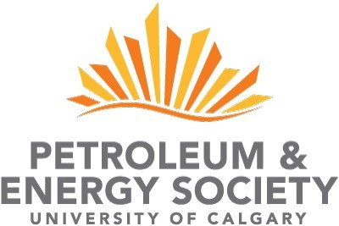

[info@pesucalgary.ca](mailto:info@pesucalgary.ca) | [www.pesucalgary.ca](http://www.pesucalgary.ca/)